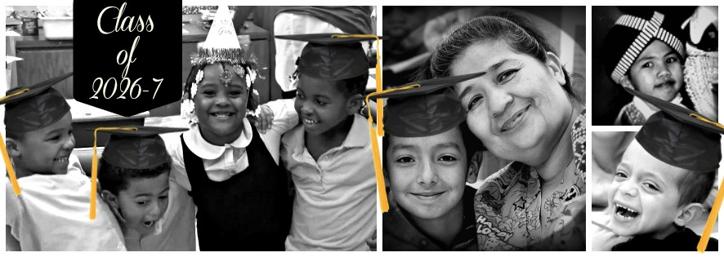

We Are
Kids with Big Dreams &
Families with Big Plans
Taking Steps on a Path
Together—to Succeed.

The Class of 2026-7
Invites you to
Celebrate with us
Our graduation from
Families & Schools Together
F.A.S.T.

We look forward to
Fun doing art projects with our kids & other families.
Special moments with our children “on stage”.
A delicious feast together.

Let’s celebrate the amazing class of 2026-7
Starting NOW!

F.A.S.T. Graduation is ______________________________________________
at________________________________________________________________
About this special event: 30 Philadelphia elementary schools have been hosting Families and Schools Together® (FAST®) for K-1 students with the help of volunteers and staff associated with Turning Points for Children, the nonprofit FAST, Inc., the School District of Philadelphia and the Wisconsin Center for Education Research. An independent study is being conducted by the American Institutes for Research.
Graduation is an important step for families, acknowledging their individual and interpersonal growth and commitment to equipping their children to be successful in school and life.
PhillyFASTi3 is a partnership funded by an Investing in Innovation Grant through the U.S. Department of Education (no. U411B120009).

Please come and celebrate with us!
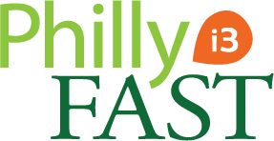
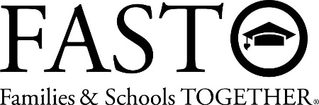
www.PhillyFASTi3.com
